Oak Grange Primary School
Foundation Stage 1
Nursery
 | Autum 1 | Autumn 2 | Spring 1 | Spring 2 | Summer 1 | Summer 2
Theme | Tiny Seeds Become Mighty Trees | Let’s Celebrate | To Infinity and Beyond | Could It Be Magic | Down on the Farm | Saving our Planet
Theme | Me, my school, my community.  School Values  People who help us | Bonfire night  Diwali  Seasons  Autumn  Birthdays  Christmas  Autumn  Winter | STEM – Woman in Space  Neil Armstrong | Building on their imagination | Environmental sounds  Where our food comes from  Animals that live on a farm. | How to look after our planet  Eco warriors
Core Books | The Colour Monster  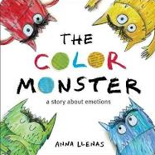  People who help us books  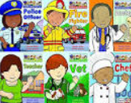 | Rama and Sita  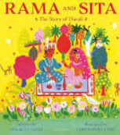  Leaf Man  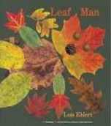 | Whatever Next  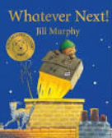  Meet the Planets  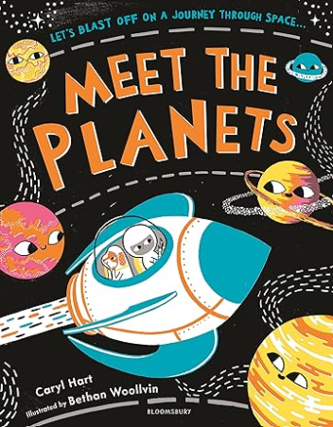 | There's a dragon in Your Book  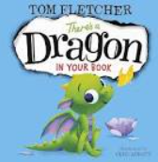  Room on the Broom  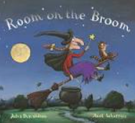 | Farmer Duck  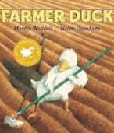  Rosie’s Walk  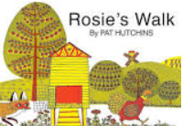 | The Odd fish  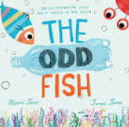  10 Things I Can Do to Help My World  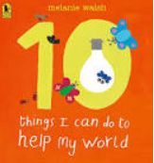
Supporting Texts | The Day the Crayons Quit  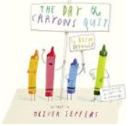  Super Daisy  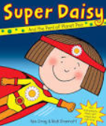  Settling into School/Nursery Books  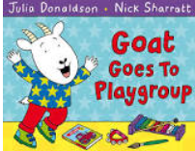  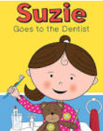  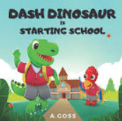 | Seasons and Sounds – Listen to Autumn  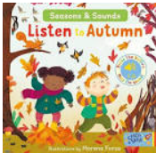  A Walk in the Woods  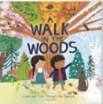  Little Acorn  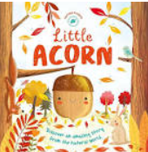  A Handful of Buttons  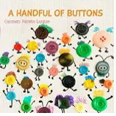  The Christmas Story  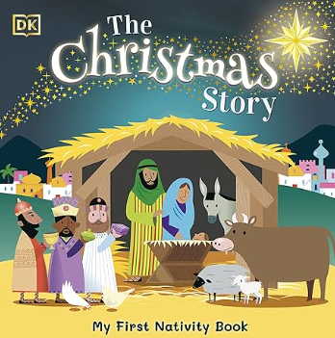 | Zoom to the Moon  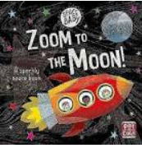  On the Moon    The Way Back Home  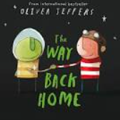 | What’s in the Witch’s Kitchen?  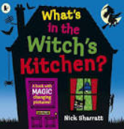  Mog  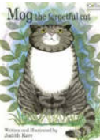  Zog  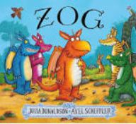  There’s a Witch in Your Book  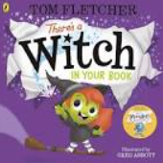 | On the Farm (Axel Scheffler)  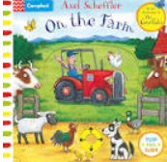  Noisy Farm  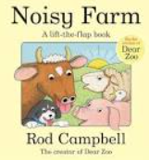  Farmyard Hullaballo  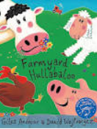  Dora’s Chicks  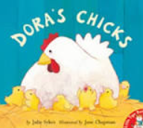  What the Ladybird Heard  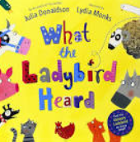 | Saving Tally  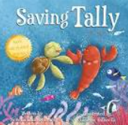  How A Recycling Truck Works  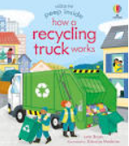  Recycling (Helping Hands)  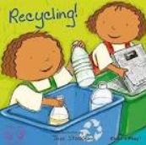  Somebody Woke Wilson  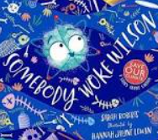  Somebody Crunched Colin  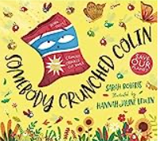
Traditional Tales | Goldilocks and the Three Bears  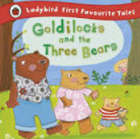 | The Elves and the Shoemaker  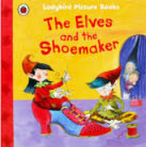 | Little Red Riding Hood  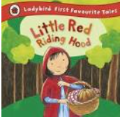 | Jack and the Beanstalk  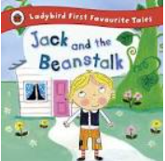 | Chicken Licken  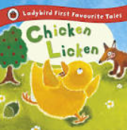 | The Enormous Turnip  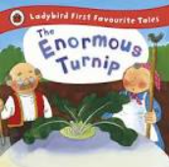
Experiences and Visitors | Vet  Police  School Nurse  MP  Teaching Staff | Make Diwali lamps  Bonfire Night/ Fireworks  Christmas Party  Visit from Santa  Theatre Trip | Derby Astronomical society  Star Gazing Night | Magic Day / Dress Up | Possible trip to Bluebells  Duck eggs in school | Waste collectors/Recycling centre  Severn Trent
Celebrations and Events | Harvest  Halloween (Half Term) | See Themes  Christmas Party | Mother’s Day | Easter | Father’s Day | Transition
Safeguarding Topic | Road Safety |  | Stranger Danger | Safer Internet | Pantosaurus | Drowning Prevention
PSHE | New Beginnings Health and Well- being (mi | Families and Relationships | Safety in the Environment | Citizenship – respecting others and our  environment | The changing body (all about me) | Transitions (new classes)  Drugs Education
PSHE Dates
 | SEPTEMBER:  - 18th – 24th Genes for Jeans Week | NOVEMBER:  - Bonfire Night 5th  - Remembrance Day 11th  - Diwali 12th-16th  - World Nursery Rhyme Week 13th -17th  - Anti-bullying Week 13th -17th  - World Kindness Day 13th  - Children in Need 17th  - Friendship Friday 17th  - Road Safety Week 19th – 25th  - International Men’s Day  - Odd Sock’s Day 20th  - St Andrew’s Day 30th | JANUARY:  - Make Your Dream Come True Day 13th  - National Storytelling Week 29th – 5th Feb | FEBRUARY:  - Children’s Mental Health Week 5th -11th  - Safer Internet Dat 6th  - Chinese /Lunar New Year 10th  - Shrove Tuesday 13th  - Valentine’s Day 14th  - Random Act of Kindness Day 17th  - World Thinking Day 22nd | APRIL:  - World Autism Awareness Day 2nd  - International Children’s Book Day  - Eid-Al Fitr 9th-10th  - Earth Day 22nd  - St George’s Day 23rd  - International Dance Day 29th | JUNE:  - World Environment Day 5th  - World Oceans Day 8th  - Father’s Day 16th  - Drowning Prevention Week 16th -23rd  - Eid-Al Adha 17th  - World Music Day 21st
 | OCTOBER:  - ADHD Awareness Month  - Black History Month  - Harvest Festival 1st  - World Mental Health Day 10th  - Global Handwashing Day 15th  - Restart a Heart Day 16th  - Halloween 31st | DECEMBER:  - Advent Begins 3rd  - Christmas Day 25th  - New Year’s Eve 31st | FEBRUARY:  - Children’s Mental Health Week 5th -11th  - Safer Internet Day 6th  - Chinese /Lunar New Year 10th  - Shrove Tuesday 13th  - Valentine’s Day 14th  - Random Act of Kindness Day 17th  - World Thinking Day 22nd | MARCH:  - St David’s Day 1st  - World Book Day 7th  - International Women’s Day 8th  - Mother’s Day 10th  - Ramadan 10th 9th April  - International Day of Mathematics 14th  - St Patrick’s Day 17th  - International Day of Happiness 20th  - World Poetry Day 21st  - World Water Day 22nd  - Easter Sunday 31st | MAY:  - Mental Heath Week 13th-20th  - Walk to school week 20th-25th | JULY:  - World Chocolate Day 7th
APRIL:
- World Autism Awareness Day 2nd
- International Children’s Book Day
- Eid-Al Fitr 9th-10th
- Earth Day 22nd
- St George’s Day 23rd
- International Dance Day 29th

Prime Areas | Communication and Language | Listening, Attention & Understanding | Children will be learning to sit quietly and develop their listening skills during whole class discussion times. They will be learning to listen and respond to: their name, sounds, stories, songs and as well as during conversation. They will be able to ask simple questions (who, what, where?) and begin to answer why and how questions. Children will develop their skill to recall stories, understand and follow instructions and understand humour. We will also work with the children to help them become more expressive so that they can share their ideas, experiences and understanding. They will also develop their ability to ask questions, explain themselves and use a wide and varied vocabulary.
Prime Areas | Communication and Language | Speaking
Prime Areas | Physical Development | Gross Motor Skills | Children will develop their gross motor skills through outdoor play; running, climbing, balancing, crawling etc. They will develop their ability to move safely too, developing core muscle strength, stability, coordination and balance. This will also involve negotiating obstacles, using wheeled toys and climbing equipment. They will also develop their core strength through daily tummy time and ‘Squiggle Whilst You Wiggle’.
Prime Areas | Physical Development | Gross Motor Skills | Climbing the frame and descending the pole safely. | Riding wheeled vehicles safely and with control. | Ball skills – throwing, catching and kicking. | Balancing – on one foot, on different parts of our bodies and on equipment. | Moving in different ways – crawling through tunnels, rolling in different ways and jumping. | Yoga – bending and stretching and holding a pose.
Prime Areas | Physical Development | Fine Motor Skills | Children will be developing fine motor skills such as pencil grip, scissor control, using cutlery, manipulating small objects (e.g., threading, jigsaws) developing hand strength using malleable materials and when using writing tools. The children will have continuous access to daily fine motor activities, and they will also take part in dough disco, ribbon writing and finger exercise songs.
Prime Areas | Physical Development | Health and Self-Care  RSE | Children will be taught how to become independent in their self-care skills. This includes, toileting, hand washing, feeding and drinking appropriately as well as putting on and taking off their own coats and shoes. The children will also learn to understand why hygiene is important, to appreciate and value their body, its capabilities and uniqueness and to name some parts of their body

Prime Areas | Personal, Social and Emotional Development | Managing Self | We will be helping the children to become more confident, to express themselves, to explore the different resources and to interact with others. We will also help the children to share, take turns and play cooperatively. Children will be encouraged to be resilient and to develop a “can do” attitude to help them on their learning journey. As the children progress throughout the year, adults will set jobs to encourage children to become more responsible for their own learning. Furthermore, we encourage this responsibility and resilience in their personal hygiene and self-care skills.
Prime Areas | Personal, Social and Emotional Development | Self-Regulation | We will introduce the “School Values” to the children and set high expectations of behaviour. We will help the children develop strategies to develop their feelings and behaviours and how to handle their emotions. Children will take part in regular mindfulness activities within the setting.
Prime Areas | Personal, Social and Emotional Development | Building Relationships | We will support the children to make friends, think about what a good friend is and to develop friendships. We will also help children to recognise other people’s feelings and interests. We encourage children to show an interest in others and to embrace their similarities and differences.
Prime Areas | Personal, Social and Emotional Development | PSHE Themes | New Beginnings | Families and Relationships | Safety in the environment | Citizenship (Respecting others and our environment) | Growing (What can you do now that you couldn’t when you were younger?) | Transitions (new classes)
Prime Areas | Personal, Social and Emotional Development | RSE | To learn that we are part of the nursery group. To learn the names of our friends and the school values and class rules of the nursery | To learn what is, and how to be, a good friend. To learn that families can be different and that families love and care for each other. (A Handful of Buttons) |  |  | Know that animals (including humans) grow and have babies. (Summer lifecycle topics) | Understand that they have changed since starting nursery and can say some of the things they can do now that they couldn’t do before.
Prime Areas | Personal, Social and Emotional Development | Drug Education |  | Recognise hazards and danger | Medicine safety | Who to go to for help |  | Choices – peer pressure

Specific Areas | Literacy | Comprehension and Word Reading | Children will be listening to a range of stories during story time and will also look at a range of texts (fiction and non-fiction) during our topics. Story times are planned to ensure the children are introduced to the skills of comprehension. The children will have access to a book corner in the nursery and visits to the school library to encourage them to develop a love of books and reading! We will work with the children to help them recognise print in the environment. We will begin to retell stories through role play and small world play and begin to think about how stories are structured. We will take part in Phase 1 Letters and Sounds, embedding the early phonic learning skills in all children
Specific Areas | Literacy | Writing | We will encourage the children to explore different ways of mark making using a variety of resources. We will help the children to learn and develop their pencil control and gain confidence in mark making. We shall also provide opportunities for mark making with a purpose, to write their name, to form letters, numbers, shapes and other pictures. Children will be encouraged to use their writing skills in their play.
Specific Areas | Literacy | Writing | Give meaning to marks they make as they paint and draw. | ‘Write’ a letter to Father Christmas asking him to come to school | Name writing – focus on a letter at a time. | ‘Write’ a potion of their choice for the topic. | Name writing – how many letters can they write now? | Saving Our Planet – choose a sea creature mark make about
Specific Areas | Mathematics | Number and Number Patterns | Children will be developing their number understanding and skills in a variety of ways, both through discrete teaching and practical activities. We will enjoy number songs and stories and provide opportunities in their play. The continuous provision allows for children to explore number and create and solve their own mathematical problems.
Specific Areas | Mathematics | Number and Number Patterns | Rote counting | Touch counting  Numbers 1-4 | Number recognition | Link numerals and amounts  Numbers 5-7 | 1 more and 1 less | Simple addition with objects  Numbers 8-10
Specific Areas | Mathematics | Shape, Space and Measure | Children will take part in lots of practical activities involving shape and measure in all areas of the nursery (eg sand pit, water tray, construction area) This will help them to develop the language and understanding of size and shape. We will encourage the children to make comparisons between different objects.
Specific Areas | Mathematics | Shape, Space and Measure | 2D shapes – shape hunt – what shapes can you find in Nursery? | Prepositions – where is the Elf from the Elves and the Shoe Maker? | Repeating Patterns – can you create a repeating pattern with the stars and moons? | 3D shapes – what shapes can we use to create models of castles? | Compare size – which animal is the tallest/shortest? Which animal is the heaviest/lightest? | Sequence events – describe the sequence of making the kite using words such as first and then.
Specific Areas | Understanding the World | UTW | Children will be: Talking about themselves, their families and their interests. Sharing thoughts and experiences about families and developing an understanding that families can have similarities and differences. Sharing knowledge about different people in the community and thinking about people who help us. Talking about those that are important to them and why. Learning and sharing experiences of different festivals and how they are celebrated.
Specific Areas | Understanding the World | Past and Present | Special people –  drawing pictures  of our family | Let’s Celebrate -  Our family Tree | To Infinity and Beyond – First Woman in Space | Could It Be Magic – Castles – who lives in them – ruins of castles and castles that are lived in | Down on the Farm – who has been to a farm, can they talk about experience/ | What can I do now that I couldn’t when I started Nursery?
Specific Areas | Understanding the World | People, Communities and Culture | Harvest Festival Bonfire night | Diwali Christmas | Topic – the countries of the first astronauts in space - Know that there are different countries in the world. Talk about where we have been on holiday. Chinese New Year Mother’s Day | People who help us – learn about the occupations of people in our community.  Easter | Father’s Day | Transition – our school community
Specific Areas | Understanding the World | The Natural World | The children will be provided with lots of opportunities to; learn and recognise signs of the changing seasons, explore using their senses, notice changes in the weather and their local environment. They will learn about the growth and life cycles of plants and mini-beasts and also learn about habitats. They will think about their local environment and observe local buildings and signs on the road safety walk. They will learn about different animals and think about their similarities and differences.
Specific Areas | Understanding the World | The Natural World | Discover and explore the Nursery environment. | Why do the elves need new clothes without holes? Why has the snowman melted that the elf brought back! | Bare foot walk …..Feel those textures on your toes! | Shadow play – create your own ‘magic’ shadow puppets show. | Growing – how to grow and care for plants. Looking after the Nursery garden. The lifecycle of a bean. Link to farms and the topic | Respect and care for the natural environment. Taking litter home, don’t pick the flowers, pollution etc linked to books.
Specific Areas | Understanding the World | Technology | Children will explore with technological toys, torches, and remote-control vehicles.
Specific Areas | Expressive Art and Design | Creating with Materials | We will help the children to explore a range of different materials and encourage children to think about their texture and colour. We will teach children how to use different craft materials, tools and techniques to create pictures and models. We will also develop children’s understanding of colour and learn how it can be mixed to create different effects. The children will have continuous access to a making area with a wide range of open-ended resources to practice and hone their creative skills.
Specific Areas | Expressive Art and Design | Creating with Materials | Draw or paint a self-portrait Colour mixing | Create pictures inspired by the sounds and sights of fireworks | Learn how to roll paper to create a tube to create a telescope. | Learn how to fold paper to create a fan | Collage with beans and seeds and explore the textures of them | Create salt dough models of sea creatures
Specific Areas | Expressive Art and Design | Artists and Genres that we will be inspired by this year |  | Jackson Pollock – firework painting based on the book Jackson Pollock splashed paint and didn’t care’ | Alma Thomas – Space based paintings |  | Vincent Van Gogh  ‘Sunflowers’  Link to our Growing Topic
Specific Areas | Expressive Art and Design | Being Imaginative and Expressive | We will help children to develop their ability to explore different ways of expression through singing, dancing and imaginative play. We will also provide open end resources so that the children have the opportunity to use and develop their imagination. The children will have constant access to a role pay area which will be changed regularly to reflect children’s interests and topics. We will have lots of fun exploring musical instruments and learning how to change their sound.
Specific Areas | Expressive Art and Design | Role Play Areas | Home Corner  Dentist | Home Corner  Santa’s workshop | Home Corner  Space Centre | Home Corner  Potion Shop | Home Corner  Farm Shop | Home Corner

